import java.util.\*;

public class Hello {

public static void main(String[] args) {

Scanner sc=new Scanner(System.in);

String str=sc.nextLine();

int a=sc.nextInt();

//ArrayList<Integer> arr=new ArrayList<>();

String arr="";

String b="";

for(int i=0;i<str.length();i++){

if(Character.isDigit(str.charAt(i))){

arr+=str.charAt(i);

}

else{

b+=str.charAt(i);

}

}

int c=0,len=arr.length()/(a\*a),ans=len;

for(int i=0;i<a;i++){

for(int j=0;j<a;j++){

System.out.print(arr.substring(c,len)+" ");

c=len;

len=len+ans;

}

System.out.println();

}

int sum=0;

for(int i=0;i<a;i++){

for(int j=0;j<a;j++){

System.out.print(b.charAt(sum)+" ");

sum++;

}

System.out.println();

}

//System.out.print(arr+" "+b);

}

}

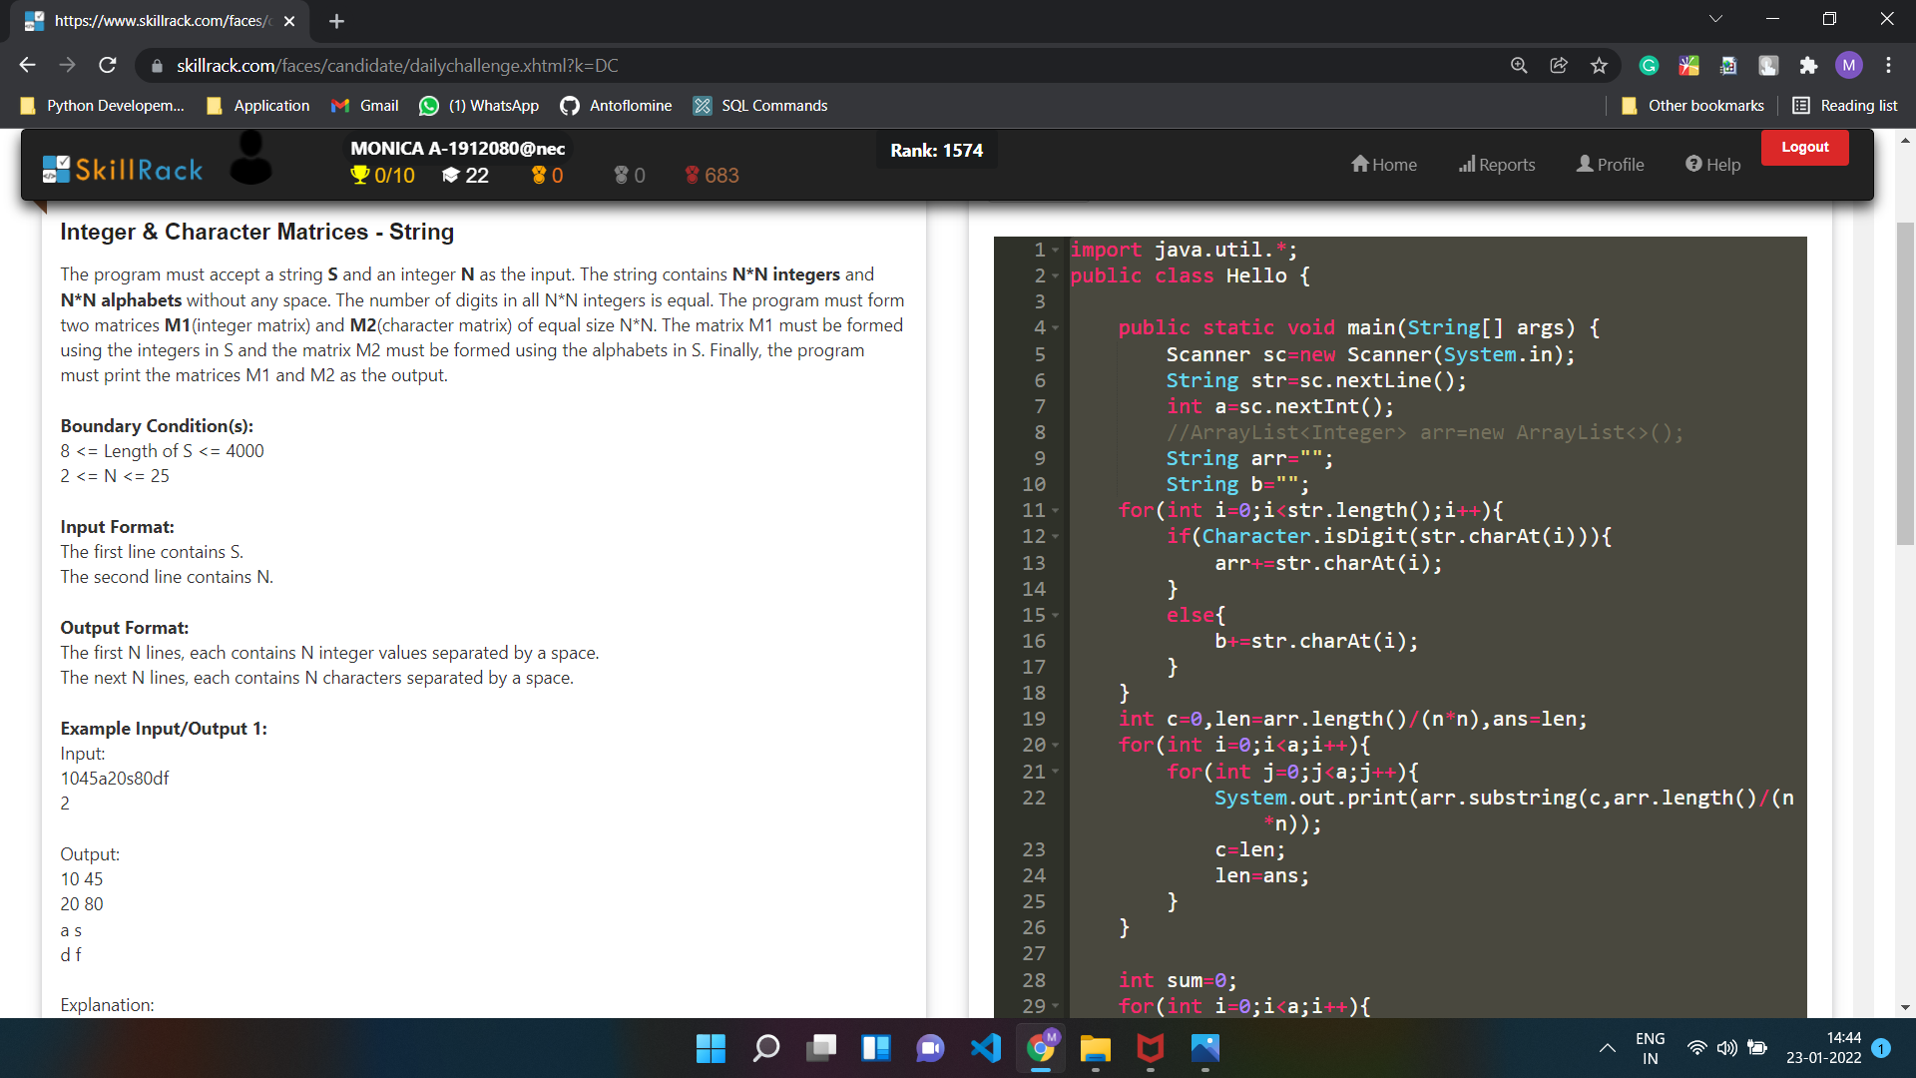

import java.util.\*;

public class Hello {

public static void main(String[] args) {

//Your Code Here

Scanner sc=new Scanner(System.in);

String s;

boolean f=false;

while(sc.hasNext()){

s=sc.next();

if(s.equals("CAPSLOCK")) f=!f;

else if(s.startsWith("SHIFT+")){

s=s.substring(6,s.length());

if(f) System.out.print(s.toLowerCase());

else System.out.print(s.toUpperCase());

}

else if(!f) System.out.print(s);

else System.out.print(s.toUpperCase());

}

}

}

